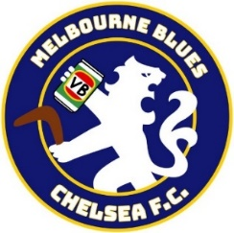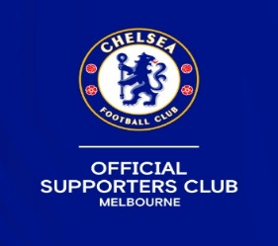

MCSC Membership Form 2026/27 (New members ONLY)
THINGS TO CHECK BEFORE YOU EMAIL THIS FORM TO US
1. Have you changed the file name?
2. Have you cc’d the TWO club email addresses?
3. Have you paid the correct amount?
Please just ‘EDIT’ this doc to add your information (don’t print and handwrite)
Please add some details about yourself by answering these few questions
If more than one person is on this form, then each person to complete these questions: -

1. What is your age? 18-30 31-40 41-50 50+
2. How long have you lived in Melbourne/Victoria?
3. What year did you start supporting Chelsea FC?
4. Have you already been buying the paid membership with CFC in London on a regular basis?
6. Do you follow any of our social media? If yes, which ones and how long for.
7. Have you been to our chosen pub to watch Chelsea on TV in the city?

Ensure your “NAME” and “MSHIP FEE” is put on the EFT transaction. (Bank info at bottom of this form)
Change the file name of this edited doc to include your name please.
send an email to admin@chelseafcinmelbourne.com
and cc membership@chelseafcinmelbourne.com
Please put “Membership 2026/27” in the subject heading when emailing everything back to us.
If you are a member with CFC in London already, please put your 8-digit membership number/Supporter ID next to your name(s)
NAME
ADDRESS
POST CODE
MOBILE
EMAIL
2nd person
3rd person
4th person
Additional email addresses
(if they want to be on our mailing list too)
$65 for 1st membership (if in metro Melbourne) and $45 for any additional member.
A 4th membership is free, buy three and get one free
All fees include the membership items being posted to your supplied address. (no PO boxes please)
Country Victoria/Inter-state/International* members pay $45.
(*International postage fee will be added)
Our Preferred payment is via EFT to our club account with reference “MSHIP”
Club account name “MCSC” Bendigo Bank - BSB 633000 Account number 167877786
“PayID” to 0421 441075
PayPal to admin@chelseafcinmelbourne.com “Friends” option please.
For 2026/27 the MCSC merchandise is a toiletries bag, string backpack, charging cable, season badge, membership card, and bumper sticker. See our website for photos.
In the unlikely event of merchandise running out, we will substitute with items from previous seasons.
Additional members below (family or household)

